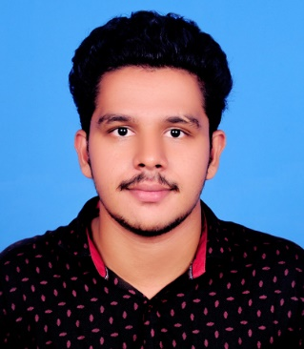

Coding

Testing

Designing

SKILLS

1. Cry Trans – Decentralised Crypto wallet and Messenger using Vue js, Solidity and node js

2.Document Verification System – Blockchain based document verification system using Solidity, Mongo dB, Ganache

3.Road transport Management system – Using php and MySQL

**ACADAMIC PROJECTS**

Photography

Graphic Designing

Hindi

Tamil

ENGLISH

Kerala University

**Higher Secondary** **2016-2014**

St Johns Model Higher Secondary School

Percentage: 81.3%

**Secondary Education** **2016-2018**

Lourdes Mount Higher Secondary School

Central Board of Secondary Education

Percentage: 83.6%



arunmohan2723@gmail.com



+917994045476

**EDUCATION**

**Master Of Computer Application** **2019-2021**

Mohandas College of Engineering

Kerala Technical University

Percentage: 73.3%

**B.Sc. Computer Science** **2016-2019**

University Institute of Technology

Percentage: 64.59%

Candidate with an intermediate level of technical and programming skills. Seeking to utilise broad educational background with excellent analytical, testing, designing and programming skills as a software tester. Quick at learning new concepts and technologies, researching test tools and implementing them to use.I would like to persue my career as a software tester because of my intrests in designing and testing.

**ARUN MOHAN**

HOBBIES

LANGUAGES



Arunima, Krishnapuram,

Mudackal P.O

Venjaramoood

Trivandrum, Kerala

Pin: 695103

CONTACT